Student Payroll Guide
This guide outlines procedures, policies, and instructions for student employment and payroll at Minnesota State University Moorhead (MSUM).

Student Payroll Contact
Human Resources, Owens 214
Phone: 218.477.2223
Fax: 218.477.2123
Email: studentpayroll@mnstate.edu

Quick Links
eServices – Student & Supervisor Timesheets

Important Dates
- 06/30/2026 – Last day of FY26.
- 07/01/2026 – Beginning of FY27 (new authorizations needed).
- 07/28/2026 – Last day of summer work study.
- 07/29/2026 – Fall semester start date for work study authorizations.
- 12/18/2026 – Last workday for students not attending spring semester.
- 05/08/2027 – Last workday for students who will not be returning summer or fall.
- 06/30/2027 – Last day of FY27 (new authorizations starting 7/1/2027).

Table of Contents
Student Payroll Guide 1
Student Payroll Contact 1
Quick Links 1
Important Dates 1
Student Employee Payroll Overview 4
1: Determine Employment Eligibility 4
Credit Requirements (minimum) 4
Graduate Assistant Employment Policy 4
2: Employment Paperwork & FERPA Training 5
FERPA Training 5
A: Domestic Students 5
Minnesota Residents Claiming Exemption 5
North Dakota & Michigan Residents (Reciprocity) 5
B: International Students 6
Returning Domestic Student Employees 6
Returning International Student Employees 6
3: Work Authorizations 7
Work Authorization Forms 7
Undergraduate Regular Funds Authorization 7
Graduate Assistant Regular Funds Authorization 7
Work Study Authorization 7
4: Direct Deposit Setup 7
Campus Wage Rates 8
Undergraduate Wage Rates 8
Graduate Student Wage Rates 8
FICA & Affordable Care Act 9
FICA/Medicare: Exempt Students 9
FICA/Medicare: Non-Exempt Students 9
Affordable Care Act 9
5: eTimesheets 10
Deadlines/Timelines 11
Reporting Hours 11
eTimesheet Review & Approval (Supervisor) 11
Approving Time Worked 11
Edit eTimesheets 11
Grant Proxy 11
Rosters & Lump Sums 12
Rosters 12
Reports 12
Other Policies 13
Meal and Rest Breaks 13
Holidays 13
Overtime 13
Maximum Hours – Domestic 13
Maximum Hours – International 13
Academic Breaks 13

Student Employee Payroll Overview
- Determine employment eligibility.
- Complete employment tax forms (Domestic or International as applicable).
- Submit Work Authorization form
  - Completed by Student Payroll/Lump Sums, Graduate Assistants, Work Study.
  - Completed by employing department/All other.
- Set up Direct Deposit
  - In eServices under the ‘Student Employment’ tab.
- Submit eTimesheets (Student) and approve them (Supervisor).
Note: Students must not begin working until cleared for payroll and active in eServices.

1: Determine Employment Eligibility
To be eligible to work as a student employee at MSUM, the student must be registered and pay for credits through MSU Moorhead and must be in good standing (no holds). Metro College Alliance or MSCTC students attending classes at MSUM are not eligible. PSEO students are eligible if currently enrolled at MSUM.

Credit Requirements (minimum)
- Regular Funds Position:
- Summer Session: Enrolled for a minimum of 1 credit during summer session or pre-registered for a minimum of 1 credit for fall.
- Fall/Spring Semester: Enrolled for a minimum of 1 credit during the semester of employment.
- If an undergraduate student falls below 6 credits, or a graduate student falls below 3 credits (academic year) or 2 credits (summer), they are subject to FICA/Medicare; the department is responsible for employer share.
- Work Study Position:
- Summer/Fall/Spring: Enrolled for a minimum of 6 credits during the semester of employment. Falling below 6 credits disqualifies work study. If this occurs in summer, the entire award will be withdrawn and earnings must be covered by departmental funds.

Graduate Assistant Employment Policy
See Graduate Assistant employment policy and procedures. Graduate Assistant Employment Policy (MSUM Policies)
Graduate Assistant positions will be able to work up to 20 hours per week and will be compensated as Graduate Assistants. All Graduate Student position authorizations will require approval by the Office of Graduate Studies.
Employment as a Graduate Assistant should:
- Enrich the learning experience of the graduate student;
- Provide services to the department, program, and university that advance the student's graduate study.

2: Employment Paperwork & FERPA Training
If the student has not been employed at MSUM before, please complete step A or B below.
If they have worked on campus before, please see the “Returning Domestic Student Employees” or “Returning International Student Employees” section and complete Step 3.

FERPA Training
Departments must notify their student employees about their rights under FERPA and as employees of the University, the students must be trained in FERPA regulations annually. Retain a signed copy in your department; no need to send to Student Payroll or the Registrar.
Learn more about FERPA and training resources: MSUM Registrar – FERPA

A: Domestic Students
I-9 Employment Eligibility Verification: Domestic and International students will complete their I-9 with Student Payroll in Human Resources. Copies or faxed copies of the student’s identification will not be accepted.
Students must complete Section 1 and present original identity documents by the close of business on the third day of employment. Student Payroll will complete and sign Section 2 verifying identification. Employers may not request specific documents.
Common forms of ID include: passport, passport card, driver’s license, student ID card, birth certificate, social security card.
W-4: Use current calendar year W-4 forms for both State and Federal. If a student employee chooses to be exempt, they must complete new Federal W-4 and W-4MN each calendar year. If errors are present, Student Payroll will revert to the standard deduction.

Minnesota Residents Claiming Exemption
W-4MN: Minnesota residents claiming exemption must submit a new W-4MN prior to each new calendar year or they will default to the standard deduction.

North Dakota & Michigan Residents (Reciprocity)
MWR (Reciprocity): ND and MI residents must complete the MWR Reciprocity form each calendar year by February 15. Michigan residents also complete MI-W4 by February 15.

B: International Students
New international student employees must visit Student Payroll in Human Resources to complete initial payroll setup and tax forms. Bring hard-copy passport, I-94, I-20, and social security card. Students must have a social security number before starting employment; those without one must apply and obtain a card first.
FERPA: Employing departments should complete and file FERPA training as above.
F-1 Verification: Departments complete Section 1 of the Verification of F-1 Student On-Campus Job form and refer the student to the Office of Diversity, Inclusion, and Global Engagement for Section 2 (if employed in your department).
- International Required Tax Considerations:
- Students qualifying for U.S. tax exemption must submit new Tax Treaty Form 8233 & Attachment after December 15 and prior to the new calendar year.
- International students are exempt from FICA/Medicare. Permanent resident aliens are not exempt.

Returning Domestic Student Employees
Complete annual FERPA form. New exemption forms (Federal and State) are required by February 15 for those claiming exemption; otherwise, tax forms need not be updated.

Returning International Student Employees
Complete annual FERPA form. Verify with Student Payroll that forms are current. Only international student employees with treaty exemptions must complete new 8233 forms after December 15 and prior to the new calendar year (Student Payroll will notify by email). International students remain exempt from FICA/Medicare; permanent residents are not exempt.

3: Work Authorizations
Once tax forms are input/updated, departments may enter work authorizations in ISRS. Authorizations requiring additional review (Work Study, Graduate Assistants, Contracts, Lump Sums, Rosters) should be submitted to Student Payroll for entry. After approval, students will be able to enter time via eTime.
Submit complete forms to avoid delays; incomplete forms will be returned.

Work Authorization Forms

Undergraduate Regular Funds Authorization
Regular funds authorizations may use start dates from July 1 to June 30 of the fiscal year. After entry, undergraduates can enter time in eTime.

Graduate Assistant Regular Funds Authorization
All Graduate Assistant authorizations must be approved by Graduate Studies, regardless of cost center. Graduate Studies requires a job description for each GA position. Departments create the authorization, obtain Graduate Studies approval, and forward to Student Payroll for ISRS entry. After entry, graduate students can use eTime.

Work Study Authorization
One authorization is required for the regular academic year (Fall–Spring). Because Summer spans two fiscal years, two work authorizations are required. Students on work study cannot be paid lump sums or via contracts. Student Payroll enters these authorizations.

4: Direct Deposit Setup
Direct deposit is strongly encouraged. Students manage direct deposit via eservices, including viewing paystubs and starting/stopping/changes. In special circumstances where the direct deposit deadline is missed, the first check may be picked up in the Human Resources office. If a student is refused banking membership, a paper check will be mailed to the permanent address on file in the Registrar’s Office. Direct deposit setup applies to both student payroll and financial aid.
Access direct deposit via: eServices – Student Employment

Campus Wage Rates
Wage rates should be established at hire and based on duties and prior experience.

Undergraduate Wage Rates
Category | Rate
Minimum Hourly Rate | $13.00
Maximum Hourly Rate (without Dean/VP approval) | $15.99
Maximum Hourly Rate (requires Dean/VP approval; University maximum $17.00) | $16.00–$17.00

Graduate Student Wage Rates
Category | Rate
Minimum Hourly Rate | $15.00
Maximum Hourly Rate (without Dean/VP approval) | $17.99
Maximum Hourly Rate (requires Dean/VP approval; University maximum $20.00) | $18.00–$20.00
See wage grids on the payroll website for more details.

FICA & Affordable Care Act

FICA/Medicare: Exempt Students
The general student Federal Insurance Contributions Act (FICA) tax exemption rule states “payments for services performed in the employment of a college or university are exempt from FICA if the services are performed by a student who is enrolled at least half-time and regularly attending classes at the college or university.” International Students are always exempt from FICA/Medicare.
Undergraduate Students:
Academic Year—maintain 6+ credits;
Summer—maintain 3+ credits per session.
Graduate Students:
Academic Year—maintain 3+ credits;
Summer—maintain 2+ credits per session.

FICA/Medicare: Non-Exempt Students
If students work over 60 hours for 3 consecutive pay periods or over 80 hours for one pay period, the student and the department will be subject to FICA/Medicare tax. If you have students regularly working 30 or more hours in the summer, they are subject to FICA/Medicare taxes. Employing departments will need to complete the FICA Tax-Hire Form. We define “regularly working” as 3 out of 5 pay periods. Students working over breaks that are 5 weeks or less do not need to submit a FICA Tax-Hire Form (Ex: Christmas Break). The employing department will be charged the university’s portion of FICA/Medicare under object code 0924.
FICA/Medicare Rates:
Employer/Employee FICA 6.2%;
Employer/Employee Medicare 1.45%.

Affordable Care Act
Minnesota State System Office has determined that the Affordable Care Act (ACA) requires us to make health insurance available to student employees who average 30 hours a week or more over a 12-month period. If your student employee meets the criteria for coverage, the employer’s cost of this health care coverage will be charged back to the employing department. For more information on the employer’s cost, please contact the HR Department.

5: eTimesheets
eTimesheet approval is web-based. Student employees submit their timesheet via eServices; supervisors can view, edit, and approve both unsubmitted and submitted records.
A student’s eTimesheet becomes active in the student payroll system once the student employee work authorization is approved. If work authorization shows as inactive or missing, it may require further review.
Common Work Authorization Errors
- Work authorization not approved.
- Work authorization date expired.
- Taxes require updating.
You can view Position Details in eServices (screenshot below):
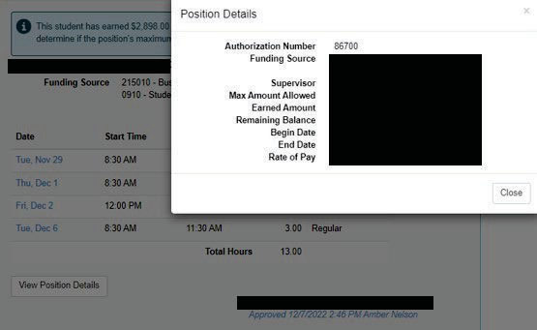
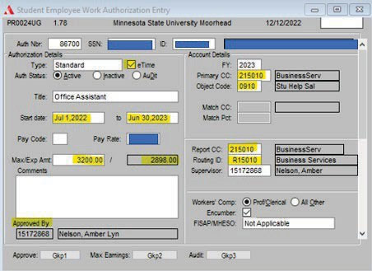
Required fields in Work Authorization Review (ISRS PR0024UG):
- eTime checkbox;
- Start/End dates;
- Fiscal Year;
- Cost Center (All cost centers with 2XXXXX must be encumbered);
- Object Code;
- Routing ID;
- Max/Exp Amt (Budget Amount);
- Approved By

If there are errors, they can be viewed by clicking into the bottom bar strip. It will provide a drop-down menu and you can see any items in error.
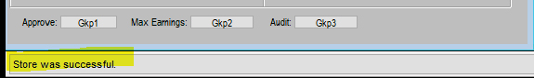

Deadlines/Timelines
See Student Payroll Calendars for pay periods, entry dates, authorization timelines, timesheet due dates, and pay dates. Timesheets are due by 4:30 pm the Wednesday of payroll week. Late approvals are processed in the next pay period; assign a proxy if you’ll be unavailable.

Reporting Hours
Report hours on the date worked within the current pay period. If you need to enter hours from a previous pay period and cannot, contact Student Payroll for assistance.

eTimesheet Review & Approval (Supervisor)
Access via ISRS Employee Home → Employee Applications → Student Payroll Supervisor.
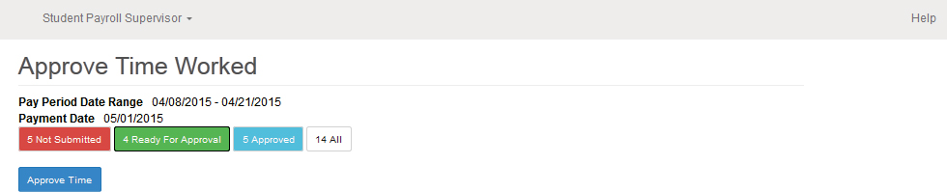
- Not Submitted (red): Displays the time worked records that have been entered by the student employees but have not been submitted. The supervisor will want to follow up with the student to have them submit their hours. Supervisors may approve un-submitted timesheets if the hours entered are correct.
- Ready For Approval (green): Review the pending records under ‘Ready For Approval’ for accuracy and to make sure no changes are needed. The timesheets need to be approved by 4:30pm Wednesday after last day of pay period.

Approving Time Worked
To approve time worked, check the certification box, then select ‘Approve Time.’ This must be done for all submitted records.

Edit eTimesheets
To edit hours, use ‘Maintain Time Worked’ to edit hours entered for incorrect time or date.

Grant Proxy
Use ‘Grant/View Proxy Access’ to assign a proxy when you are unable to approve eTimesheets during a pay period (e.g., vacation/illness).
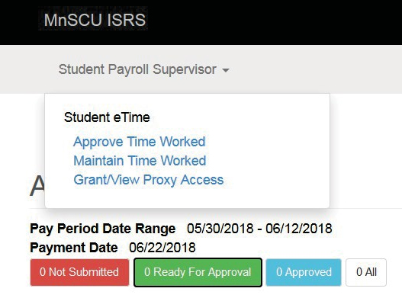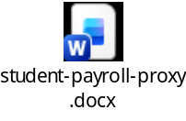

Rosters & Lump Sums
Use rosters or lump sums only when eTime cannot be used (rosters for multiple entries; lump sums for one-time payments). By choosing rosters, departments agree to retain detailed work records per the university retention schedule.

Rosters
The roster is a list of all your student employees who do not use eTime. Rosters may be used to submit hours for department student employees to the Student Payroll office. Rosters are a way to report a certain amount of pay (hours or dollars) after they have completed the work (Ex: musicians, panelist, etc.) If you choose the roster method, the department agrees to keep the student employees detailed work records in accordance with the university record retention schedule. A roster will be emailed to the supervisors on the Monday before pay period end date.

Reports
Bi-weekly department payroll reports are available in ISRS web accounting. Supervisors must review each pay period for accuracy and monitor balances. ISRS Report Instructions
Reports include:
- List of Pay Periods (PR0002GR);
- Work Authorization Report (PR0024UG);
- Student Employee Time Worked Status (PR0211CP);
- Student Employee Hours Worked Exception (PR0213CP).

Other Policies

Meal and Rest Breaks
Provide a rest break of at least 15 minutes (or sufficient time to use the nearest restroom) within each 4 consecutive hours worked. Provide a 30-minute uninterrupted meal break for shifts of 6+ consecutive hours (unpaid if completely relieved of duties).

Holidays
Hours worked on a scheduled holiday must be approved and noted on the timesheet by the supervisor.

Overtime
Overtime is almost never allowed. Coordinate across departments to ensure total weekly hours (Wed–Tues) do not exceed 40. Weekly hours over 40 are paid at time-and-a-half and prorated between departments if applicable.

Maximum Hours – Domestic
Employment should not exceed 20 hours/week while school is in session, or 40 hours/week during academic breaks and summer sessions (combined across all employment). Students averaging 30+ hours/week per calendar year may be eligible for insurance; employer costs are charged to the department.

Maximum Hours – International
Employment must not exceed 20 hours/week while school is in session, or 40 hours/week during academic breaks and summer sessions (combined across all employment). Exceeding 20 hours/week during sessions may affect U.S. work eligibility—supervisors must closely monitor.

Academic Breaks
Any time school is not in session as well as during the summer semester. The work week is Wednesday through Tuesday.

