What is illicit discharge?
Discharge to any part of the city’s storm sewer system (roads, catch basins, curbs, ditches, etc.) that is not composed entirely of stormwater is considered illicit discharge.

Illicit discharge that enters the storm sewer system contaminates stormwater and flows directly to nearby water bodies, degrading water quality and harming local flora and fauna.

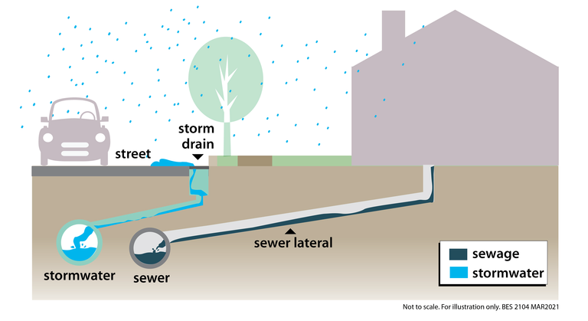
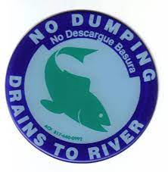
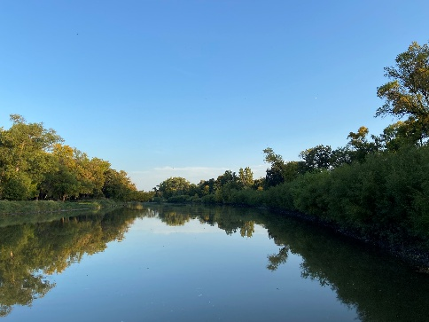

Common Pollutants

- Soil, dirt, and dediment
- Paints and dolvents
- Pesticides and herbicides
- Fertilizers
- Detergents
- Plaster
- Concrete compounds
- Asphalt compounds
- Petroleum products (fuel, oil, grease)
- Hazardous chemicals (acids, lime, glue, adhesive, curing compounds)

Be on the lookout for these common illicit discharges!

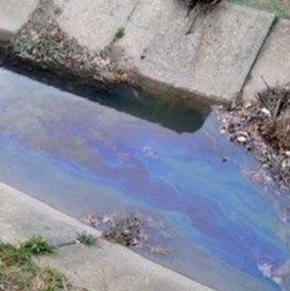 | 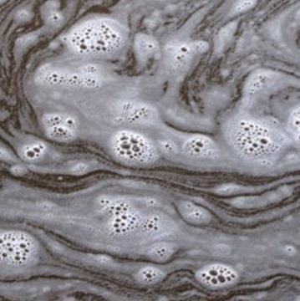 | 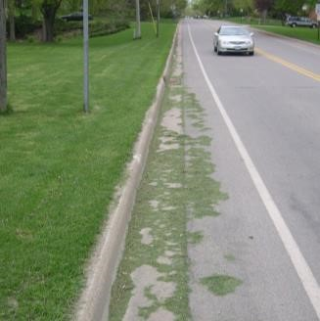 | 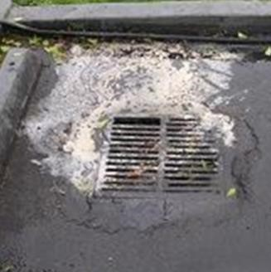
Oily Sheen | Foam, Froth, Film | Grass Clippings | Paint Residue
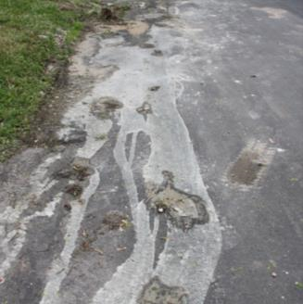 | 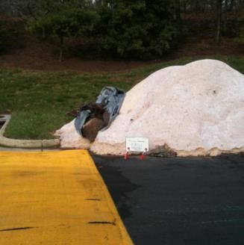 | 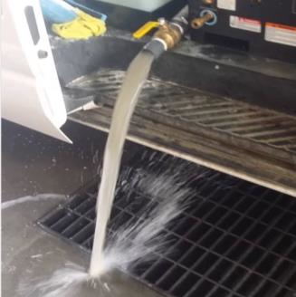 | 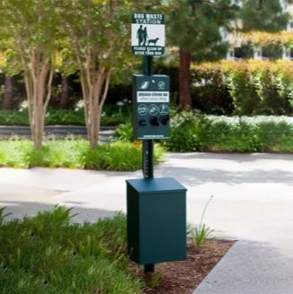
Contractor Waste | Salt | Cleaning Waste | Pet Waste
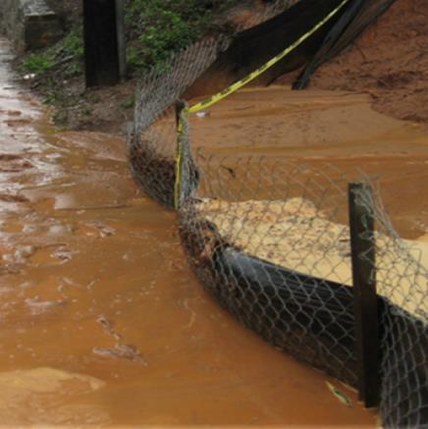 | 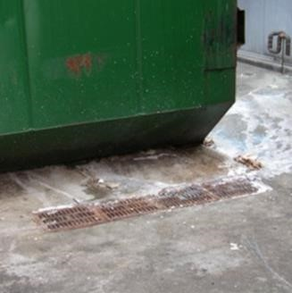 | 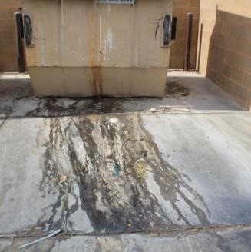 | 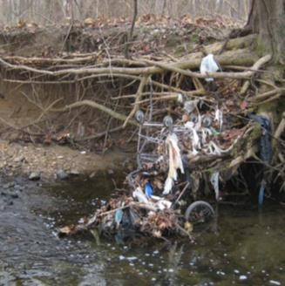
Construction Site  Runoff | Dumpster Compactor  Leaks | Grease Container  Leaks | Garbage

